Creating hub

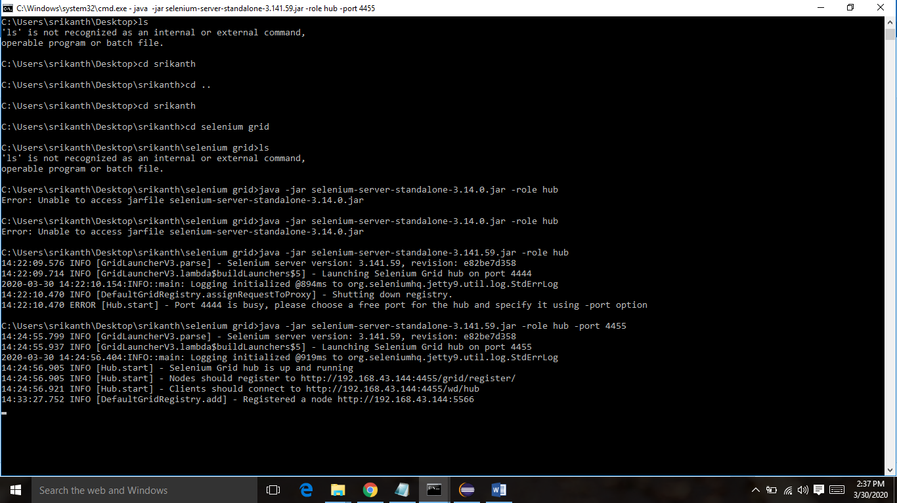

Creating node

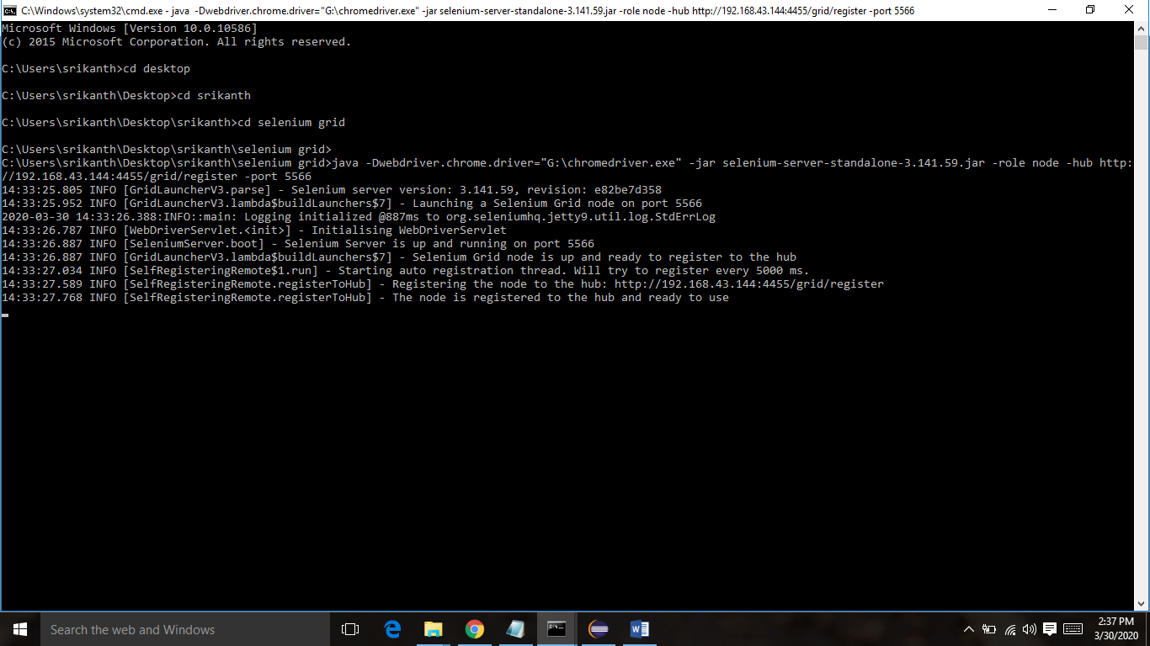

http://localhost:4455/grid/console, you will see all the browsers connected in the grid system

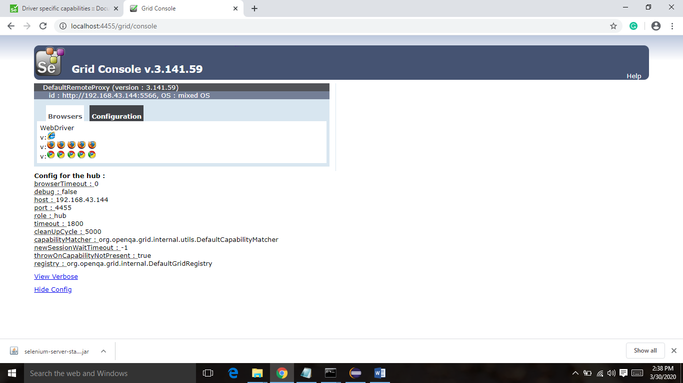

http://192.168.43.144:4455/wd/hub